Software Documentation

1. Software Overview
- What does the software do?
The software controls the complete working of the claw machine, starting from coin detection to gameplay, object retrieval, and result indication. It processes inputs from the IR sensor (coin detection), joystick (movement control), push button (claw activation), and ultrasonic sensor (object detection). Based on these inputs, the program executes logic to control outputs such as DC motors (movement), servo motor (claw operation), NeoPixel LEDs (visual feedback), and buzzer (audio feedback). It ensures smooth gameplay within a fixed time limit and automatically resets the system for the next user.

- Platforms used
MicroPython (Thonny) - for programming the ESP32 microcontroller
ESP32 - main controller handling all inputs and outputs

2. System Logic
Phase 1: Initialization (Game Start)
- User inserts coin
- IR sensor detects coin
- Buzzer plays start sound
- NeoPixel LEDs animate and then stay blue
- 1-minute timer starts
Phase 2: User Control (Movement Phase)
- User controls claw using joystick:
  - Forward/Backward → DC motor (clockwise and anticlockwise)
  - Left/Right → DC motor (clockwise and anticlockwise)
- Claw moves continuously based on input
Phase 3: Claw Operation (Pickup Phase)
- User presses push button
- Automatic sequence begins:
  - Claw opens
  - Claw moves downward
  - Claw closes (grabs object)
  - Claw moves upward
Phase 4: Transfer & Drop Phase
- Claw moves to front-left drop default position
- Claw opens to release object
Phase 5: Result Detection Phase
- Ultrasonic sensor checks for object in collection area
- If object detected:
→ LEDs turn green
→ Winning sound plays
- If object not detected (within 5 seconds):
→ LEDs turn red
→ Losing sound plays
Phase 6: Timeout Condition
- If 1-minute timer ends at any point:
- Joystick control is disabled
- LEDs turn red
- Losing sound plays
Phase 7: Reset Phase
- Result (red/green LEDs) is displayed for 15 seconds
- System resets automatically
- IR sensor becomes active for next coin

3. Flowchart
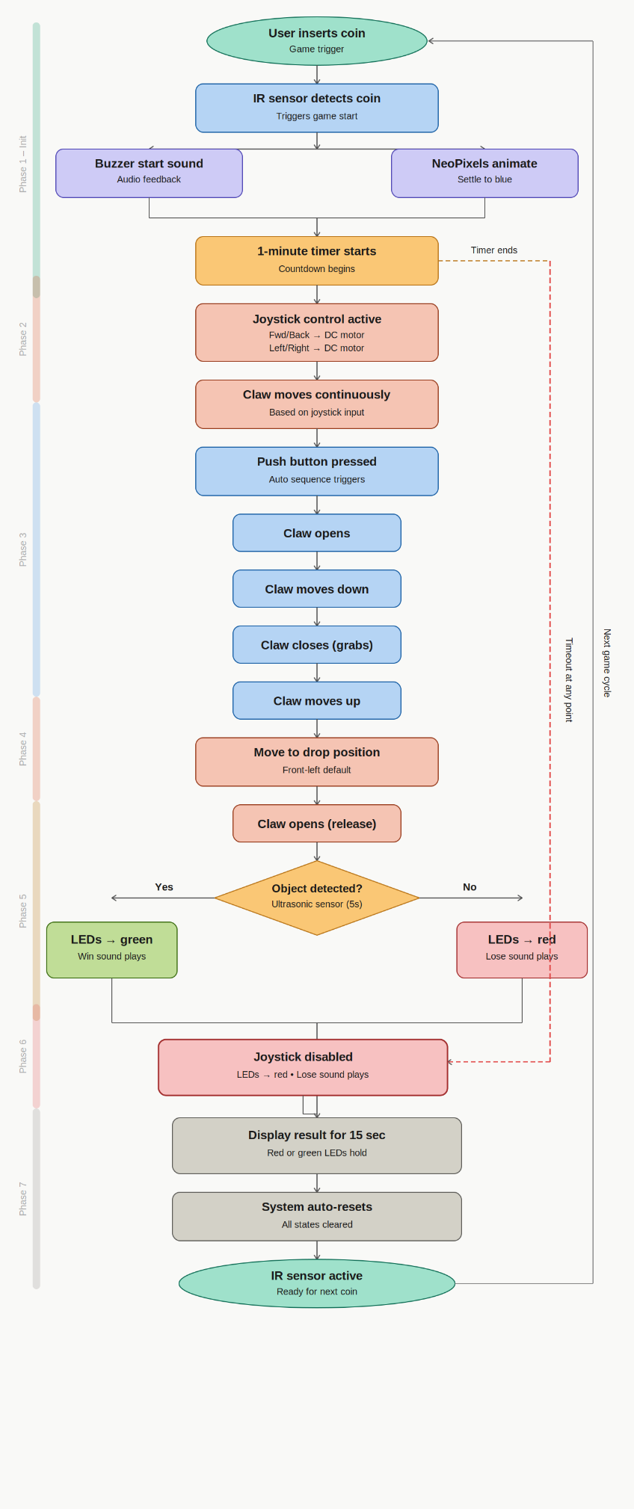

4. App Flow (If MIT App Inventor)
Not applicable (The system is fully hardware controlled using joystick and push button inputs. No mobile application or wireless communication is used)

